Mouneer Al-Shaarani
- 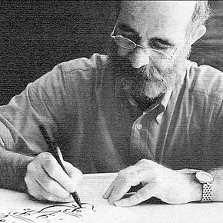
Mouneer's portrait -
Mouneer Al-Shaarani at his desk
- 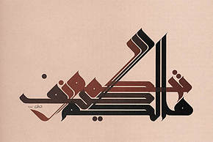
Mouneer's work -
A calligraphic piece, painting by Mouneer Al-Shaarani
Mounir Al- Shaarani is calligrapher, designer and writer, living and working in Cairo, Egypt. Born in Syria and graduated from the Faculty of Fine Arts in Damascus ( 1977). He studied under the great Syrian calligrapher, Badawi Al Dirany. He works as a calligrapher and book designer, since 1968. He has designed several custom typefaces that were used on his book covers and personal work. His work has been exhibited internationally; in Syria, Jordan, Lebanon, Egypt, Tunis, Algeria, Morocco, Bahrain, Abu Dhabi, Switzerland, France, Germany, Belgium, Italy, Yugoslavia, India, England and the USA. He is highly regarded internationally for introducing uniquely innovative calligraphic
styles and for taking his inspiration from everything around him ( old and new).

- Kufi
- , Display
- , Identity
- , Aesthetics
- , Myth
- , Craft
- , Education
- , Similar

