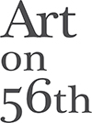

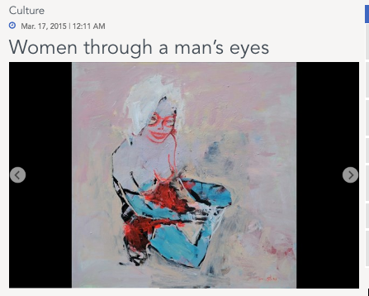

India Stoughton| The Daily Star
BEIRUT: A woman with pink trousers, matching pink hair and green arms lies face down on a bed. The curves of her buttocks and thighs are exaggerated, giving the impression that she is mostly rear-end. This vision in pink is part of Syrian artist Tarek Butayhi’s latest solo show at Art on 56th. Entitled “Women on Canvas,” it follows on from his exhibition at the same venue in February 2013, the oddly named “Women in Canvas.” In the two years since his last show, Butayhi’s approach to his preferred subject matter has shifted. Pinks, mauves and purples, pastel shades often associated with all things feminine, have replaced the somber, earthy tones of his previous paintings.
His paintings remain impressionistic, characterized by their chaotic, frantic brushstrokes and spontaneous feel. The women they capture, however, have changed. Butayhi claims to challenge stereotyped representations of the female form. His choice of color palette suggests a satirical approach to the centuries-old perception of woman as artist’s muse – an object to inspire creativity in others, to be desired, objectified and defined by the male gaze.
Even as he accentuates the femininity of his subjects, by emphasizing their curves and long, vibrantly colored hair, and overtly demonstrates their sexuality by depicting them in tight clothing or naked from the waist down, Butayhi ensures that they retain an element of individuality.
His rough style leaves them with half-finished faces and oddly proportioned limbs, stripping them of the womanly perfection and sensuousness associated with Renaissance portraiture or the bawdier, more earthy sexuality captured by modern artists such as Toulouse Lautrec. Butayhi’s women are at once objects of lust and admiration and human beings with emotions of their own.
Butayhi captures several of his subjects with cats. One woman with a bare midriff and a shock of bright red hair lies across a sofa, arm raised to stroke a ginger feline balanced on her chest. The creature’s front legs are extended, its head close to hers. Its back is arched, as if in the throes of pleasure and its tail sticks straight up in an almost phallic gesture.
The painting places the woman into a stereotyped role as a nurturing figure and giver of pleasure, but her parted gray lips and closed eyes give her a look of exhaustion, perhaps suggesting her lack of patience for these roles and giving her a vulnerability that undermines the idea of woman as a symbol.
Butayhi’s paintings are fairly uniform, each capturing a different figure but repeating many of the same motifs and compositional elements. Many of the paintings capture women lying in bed, depicted from behind, from above, from one side. Their faces are often hidden, rendering the curves of their body the sole point of interest in an otherwise mostly blank canvas.
The exaggerated curves of their buttocks and the shadowed areas between their legs render the women at once sexually suggestive and strangely grotesque, transforming them into caricatures.
One painting captures a women facing away from the viewer, on hands and knees, gazing into a featureless turquoise backdrop. The long hair that covers the back of her head is an impossible shade of fiery red. Her body is clad in a short, baby pink sundress or nightshirt. Her bare legs and the shapes of her round rear form the focal point of the painting, encouraging a sexualized gaze at odds with her posture, which evokes a crawling baby.
“Women on Canvas” marks an interesting progression from Butayhi’s earlier work. Contrasting stereotyped renditions of women as objects with an unexpected vulnerability, an overtly feminine color palette with a distinctly masculine vision, the exhibition is likely to divide viewers, leaving some amused, others appalled and many obscurely unsettled.
Tarek Butayhi’s “Women on Canvas 2015” is on show at Art on 67th until March 28. For more information, please call 01-570-331.

