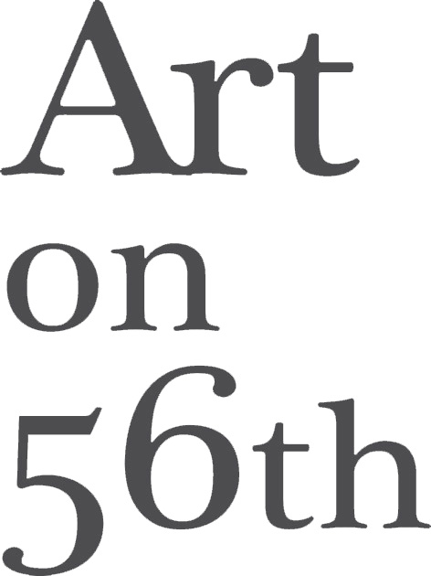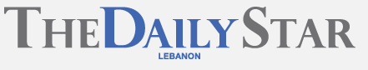

Rafik Majzoub’s portraits of an interior

BEIRUT: “Now I’m gonna just put it in a very, very simple phrase: I think I grew up to be evil.” Rafik Majzoub looks down at his hands, fiddling with a cigarette, avoiding the camera. He’s recalling his teenage years, when he spent most of his time alone, listening to music and drawing.
“I used to love to make perfect fires,” he muses. “The sound and the smells – beautiful, it was.”
There is a raw, out-of-control beauty to the artist’s newest set of paintings, one that evokes the rampage of a fire. Fleeting, wild, self-destructive – the hotter it burns, the faster it consumes itself.
“Rafik Majzoub: Memoirs of a Screw,” a beautifully shot five-part biographical documentary by Australian-Egyptian filmmaker Ann Megalla, greets visitors to the artist’s solo exhibition at Art on 56th with a harrowing introduction to the artist and his work. A self-taught outsider artist who has battled alcoholism for decades, Majzoub is as destructive as he is prolific.
Like much of his older work, that in his new solo show, “Rain on me,” consists of a series of self-portraits. The artist’s ravaged face as he captures it on his canvasses tells its own story, but Megalla’s documentary helps to place the work in a more specific context.
During the interview Majzoub takes viewers back to his childhood, when at the age of three a near-fatal car accident shattered one of his legs, making it necessary for doctors to use a metal screw to knit the bones. “The screw” became his self-imposed nickname, a fitting appellation for the lanky artist with his angular features and wild curly hair.
Majzoub was born in Amman in 1971. He moved to Lebanon in 1991, just after the official end of the Civil War. He speaks frankly about his isolated teenage years, his compulsive need for order, his phase as an arsonist and his move to Lebanon, where he soon made a name for himself as a figurative painter and a figure on the city’s burgeoning bohemian art scene.
By the mid-1990s, he recalls, he had shifted from drinking socially to drinking alone. It was the start of a lengthy, painful and destructive relationship with alcohol that would lead to a stint in rehab in 2009. This period is evoked in a series of stark, harrowing drawings in his journal “Sober Days,” which was published in 2012 by Plan Bey.
Since then, Majzoub has published two further books, each a painful documentation of days spent fighting the lure of whiskey for long enough to shower and drink some water or a cup of coffee each morning.
“Rain on me” is Majzoub’s first Beirut solo show in five years. His paintings – raw self-portraits that convey emotions far more accurately than features – have lost none of the power and fury that marked his earlier work.
Having watched the documentary, it’s hard not to see these paintings as crystallizations of an internal struggle. Majzoub was long marketed as the poster boy of a lost postwar generation. Whether or not you subscribe to this view of his art brut paintings, they pack an emotional punch that may leave viewers reeling – overwhelmed by the pain, despair, anger and seemingly unstifled hope that appear in his tortured self-portraits.
Majzoub’s self-loathing is evident in the way he describes himself on camera, as well as the mutilated self-depictions that line the walls. In person, though, he appears the opposite of “evil.” Courteous, patient and unflinchingly honest, he talks about his work, alcoholism and his uncertain future calmly and coherently.
Although his hair is now gray, he retains something of his youthful rock star image. Clad in a leather jacket and fingerless gloves, he chain-smokes and sips an espresso as he speaks. He paints self-portraits, he explains, because he doesn’t feel he has the right to disfigure someone else’s features.
“I’ve never looked at someone and thought ‘I want to paint you,’” he says. “I don’t do portraits. It’s just between me and myself, so it’s just a feeling, but in the end it’s a face. It’s me and I can do whatever I want with it. ... It’s a personal thing.”
Like the sketches in his books, his paintings often contain scrawled words or phrases.
“Try to be me” is written repeatedly in the background of one canvas. The words are overlaid with an image of the artist’s face, his head almost bald and bristling with lines – strands of hair or nails – his eyes sunken, his neck crisscrossed with marks like scars.
Another painting shows a naked figure with an emaciated body and outsized head, standing forlornly in a stream of liquid. The work is called “Wash the whiskey away.”
He may dress like a rebel, but Majzoub is not unconcerned with public opinion. Currently abstaining from alcohol, he says he won’t begin work again until he gets a sense of how the new paintings are received. Beirut is his main audience and this show is a sort of comeback, he says. Feedback is important.
There is also the question of how being sober will affect his work.
“It’s not like a Hollywood story where you would get the bottle of whiskey and play loud music and you go paint and this is the inspiration – no,” he says of alcoholism. “I was drinking 24 hours [a day], so I don’t think I was drunk. I was somewhere. It’s not like it was a process.
“I’m still in a detox stage and I’m not going to lie. I don’t know what will happen if I try to think of new work to do. I wonder, but I’m keeping it as a surprise.
“I’m enjoying lots and lots of coffee so maybe that’s kind of another high. It was a way of living so it must have affected [my work] ... If I remember correctly I was still drinking when I did all of this work.”
Whatever its genesis, Majzoub’s paintings are filled with power. Beautiful is not the word for them, he claims, but there is beauty here. It’s impossible to look at his work without feeling moved, and there’s a beauty in that raw emotion that transcends the merely decorative.
Rafik Majzoub’s “Rain on me” is up at Art on 56th though Jan. 31. For more information, please call 01-570-331.
- See more at: http://www.dailystar.com.lb/Arts-and-Ent/Culture/2015/Jan-15/284099-rafik-majzoubs-portraits-of-an-interior.ashx#sthash.ixNLSOEg.dpuf

